ASSIGNMENT -6.3
2303A52046
R.keerthisree
Batch -32
Task Description #1
(Loops – Automorphic Numbers in a Range)
• Task: Prompt AI to generate a function that displays all Automorphic
numbers between 1 and 1000 using a for loop.
• Instructions:
o Get AI-generated code to list Automorphic numbers using a for
loop.
o Analyze the correctness and efficiency of the generated logic.
o Ask AI to regenerate using a while loop and compare both
implementations.
Expected Output #1:
• Correct implementation that lists Automorphic numbers using both
loop types, with explanation
Prompt:
Code:
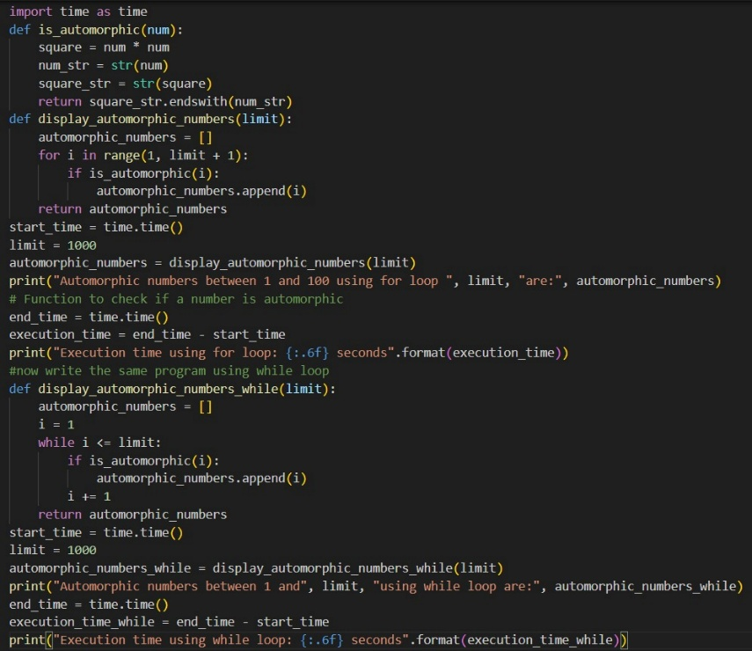
Output:
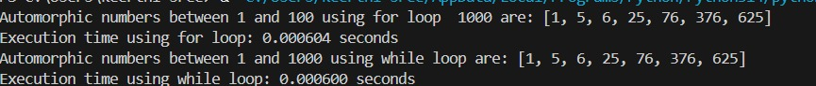
Suggestion:
Ask the AI to generate a Python program that lists all Automorphic numbers between 1 and 1000 using a for loop, where an Automorphic number is one whose square ends with the number itself. After generating the code, analyze whether the logic correctly checks this condition and whether the approach is efficient. Then ask the AI to regenerate the program using a while loop instead of a for loop, and finally compare both implementations in simple terms by explaining which loop is easier to understand and why.

Task Description #2
(Conditional Statements – Online Shopping Feedback
Classification)
• Task: Ask AI to write nested if-elif-else conditions to classify online
shopping feedback as Positive, Neutral, or Negative based on a
numerical rating (1–5).
• Instructions:
o Generate initial code using nested if-elif-else.
o Analyze correctness and readability.
o Ask AI to rewrite using dictionary-based or match-case
structure.
Expected Output #2:
• Feedback classification function with explanation and an alternative
Approach
Promot:
Code:
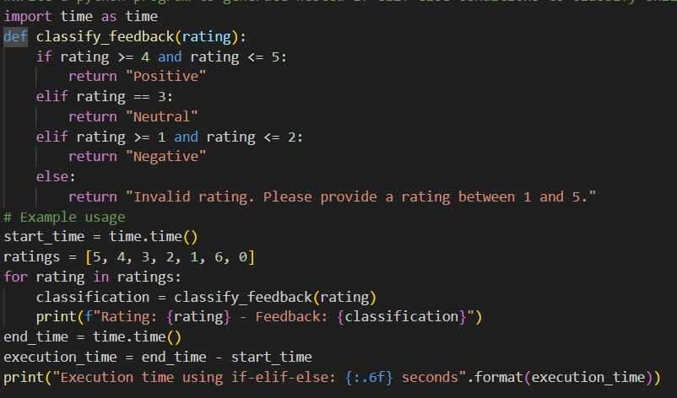

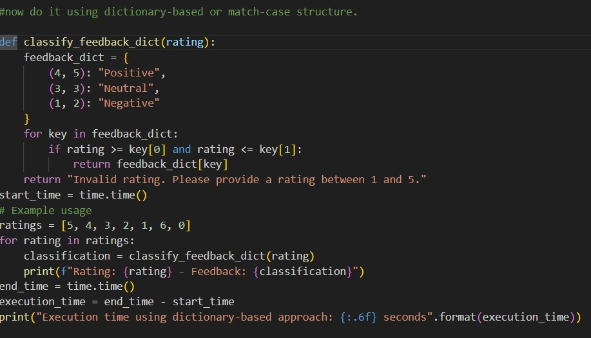
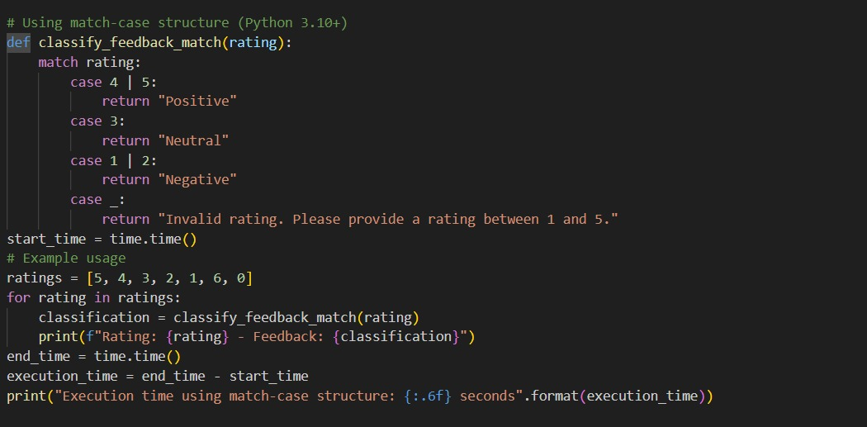
Output:
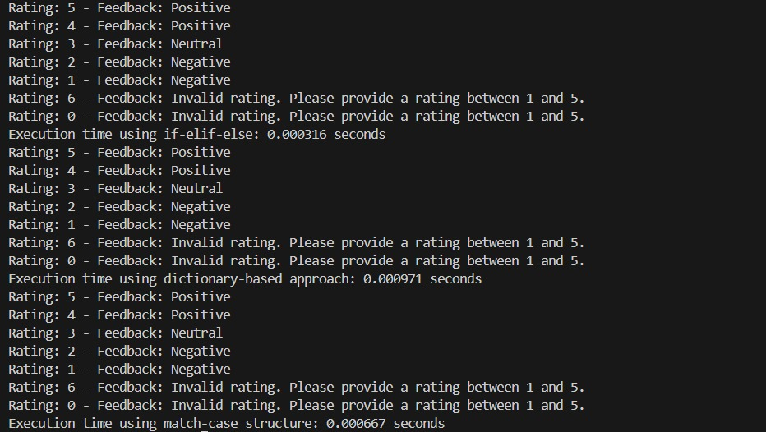
Suggestion:
Ask the AI to write a Python function that uses nested if-elif-else statements to classify online shopping feedback as Positive, Neutral, or Negative based on a rating from 1 to 5. Check whether the conditions are correct and easy to understand. Then request the AI to rewrite the same logic using a dictionary or match-case structure. Finally, ask for a simple explanation comparing both approaches and which one is clearer.
Task 3:
Statistical_operations
Define a function named statistical_operations(tuple_num) that performs the
following statistical operations on a tuple of numbers:
• Minimum, Maximum
• Mean, Median, Mode
• Variance, Standard Deviation
While writing the function, observe the code suggestions provided by GitHub
Copilot.Make decisions to accept, reject, or modify the suggestions based on
their relevance and correctness
prompt:
code:
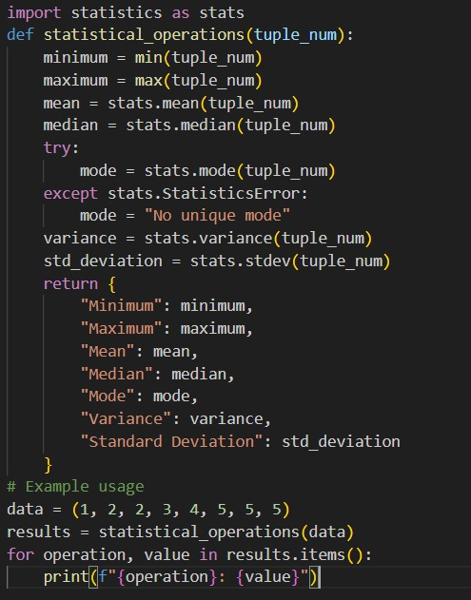
output:
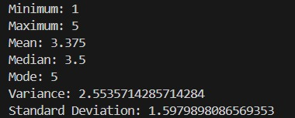
suggestion:
Ask the AI to create a Python function calledstatistical_operations(tuple_num) that calculates the minimum, maximum, mean, median, mode, variance, and standard deviation of a tuple of numbers. While writing the function, carefully review the code suggestions given by GitHub Copilot. Accept suggestions that are correct and useful, and modify or reject those that are incorrect or unnecessary. Finally, test the function with sample data to confirm all results are accurate.
Task 4:
Teacher Profile
• Prompt: Create a class Teacher with attributes teacher_id, name,
subject, and experience. Add a method to display teacher details.
• Expected Output: Class with initializer, method, and object creation
Prompt:
Code:
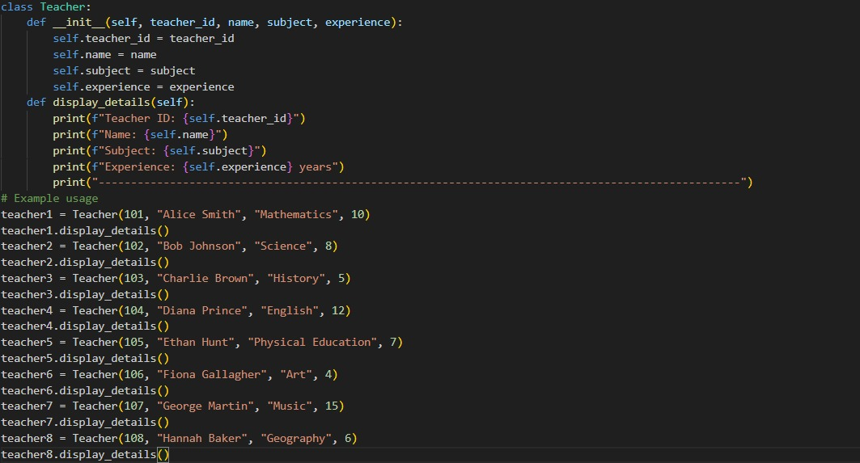
Output:
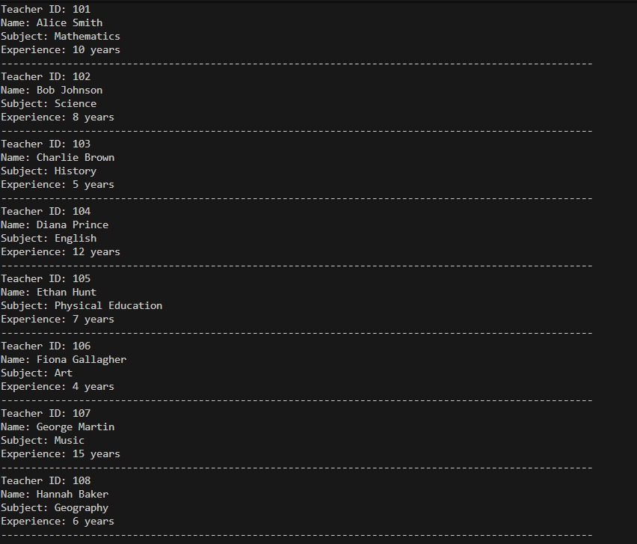
Suggestion:
Ask the AI to write a Python class named Teacher with attributes teacher_id, name, subject, and experience using an initializer. Add a method that displays all teacher details in a clear format. Then create at least one object of the class and call the display method. Finally, check that the attributes are stored and shown correctly.
Task #5 –
Zero-Shot Prompting with Conditional Validation
Use zero-shot prompting to instruct an AI tool to generate a function
that validates an Indian mobile number.
Requirements
• The function must ensure the mobile number:
o Starts with 6, 7, 8, or 9
o Contains exactly 10 digits
Expected Output
• A valid Python function that performs all required validations
without using any input-output examples in the prompt.
Prompt:
Code:
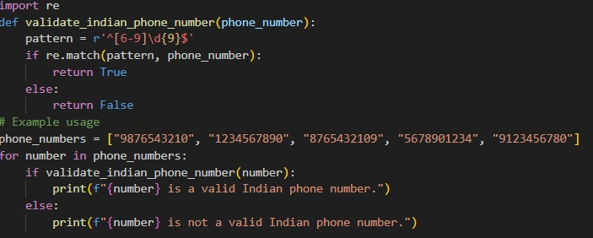
Output:
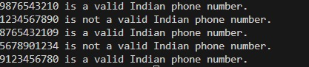
Suggestion:
Ask the AI to generate a Python function that validates an Indian mobile number using zero-shot prompting, without giving any examples. Clearly state the rules that the number must start with 6, 7, 8, or 9 and must contain exactly 10 digits. Review the generated code to ensure all conditions are checked properly. Modify the logic if needed to improve clarity or correctness.
Task Description #6
(Loops – Armstrong Numbers in a Range)
Task: Write a function using AI that finds all Armstrong numbers in a user-
specified range (e.g., 1 to 1000).
Instructions:
• Use a for loop and digit power logic.
• Validate correctness by checking known Armstrong numbers (153, 370,
etc.).
• Ask AI to regenerate an optimized version (using list comprehensions).
Expected Output #7:
• Python program listing Armstrong numbers in the range.
• Optimized version with explanation
Prompt:
Code:
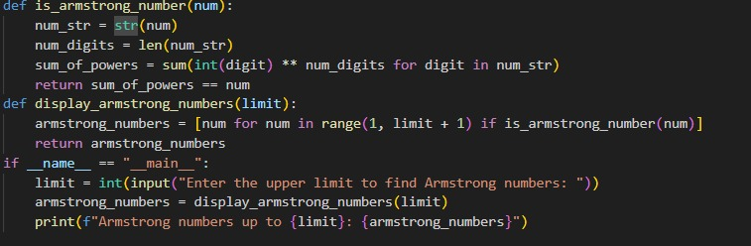
Output:
Suggestion:
Ask the AI to write a Python function that finds all Armstrong numbers within a user-given range using a for loop and digit power logic. Verify the correctness by checking known Armstrong numbers like 153 and 370. After that, request the AI to generate an optimized version of the program using list comprehensions. Finally, ask for a short explanation comparing the normal and optimized versions.
Task Description #7
(Loops – Happy Numbers in a Range)
Task: Generate a function using AI that displays all Happy Numbers within a
user-specified range (e.g., 1 to 500).
Instructions:
• Implement the logic using a loop: repeatedly replace a number with the
sum of the squares of its digits until the result is either 1 (Happy
Number) or enters a cycle (Not Happy).
• Validate correctness by checking known Happy Numbers (e.g., 1, 7, 10,
13, 19, 23, 28…).
• Ask AI to regenerate an optimized version (e.g., by using a set to detect
cycles instead of infinite loops).
Expected Output #8:
• Python program that prints all Happy Numbers within a range.
• Optimized version using cycle detection with explanation.
Prompt:
Code:
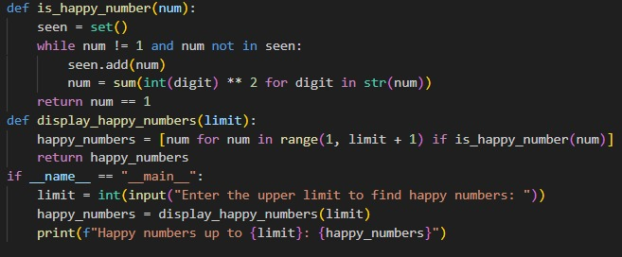
Output:
Suggestion:
Ask the AI to write a Python function that prints all Happy Numbers within a user-given range such as 1 to 500 using a loop to repeatedly replace a number with the sum of the squares of its digits. Check the correctness of the logic by testing known Happy Numbers like 1, 7, 10, 13, and 19. Then ask the AI to regenerate an optimized version of the program by using a set to detect cycles and avoid infinite loops. Finally, request a simple explanation of how the optimized version works and why it is better.
Task Description #8
(Loops – Strong Numbers in a Range)
Task: Generate a function using AI that displays all Strong Numbers (sum of
factorial of digits equals the number, e.g., 145 = 1!+4!+5!) within a given range.
Instructions:
• Use loops to extract digits and calculate factorials.
• Validate with examples (1, 2, 145).
• Ask AI to regenerate an optimized version (precompute digit factorials).
Expected Output #9:
• Python program that lists Strong Numbers.
• Optimized version with explanation
Prompt:
Code:
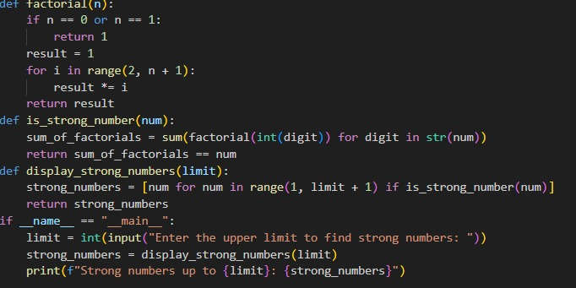
Output:
Suggestion:
Ask the AI to write a Python function that prints all Happy Numbers within a user-given range such as 1 to 500 using a loop to repeatedly replace a number with the sum of the squares of its digits. Check the correctness of the logic by testing known Happy Numbers like 1, 7, 10, 13, and 19. Then ask the AI to regenerate an optimized version of the program by using a set to detect cycles and avoid infinite loops. Finally, request a simple explanation of how the optimized version works and why it is better.
Task #9 –
Few-Shot Prompting for Nested Dictionary Extraction
Objective
Use few-shot prompting (2–3 examples) to instruct the AI to create a
function that parses a nested dictionary representing student
information.
Requirements
• The function should extract and return:
o Full Name
o Branch
o SGPA
Expected Output
A reusable Python function that correctly navigates and extracts values
from nested dictionaries based on the provided example
prompt:
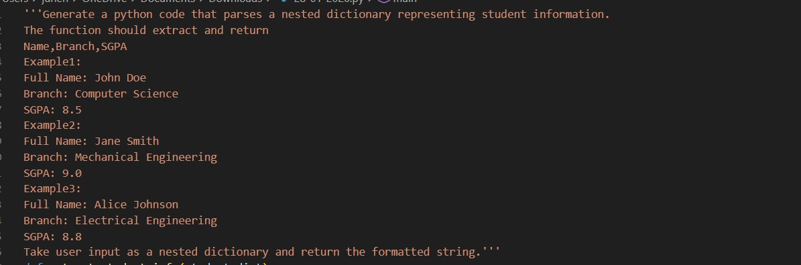
code:
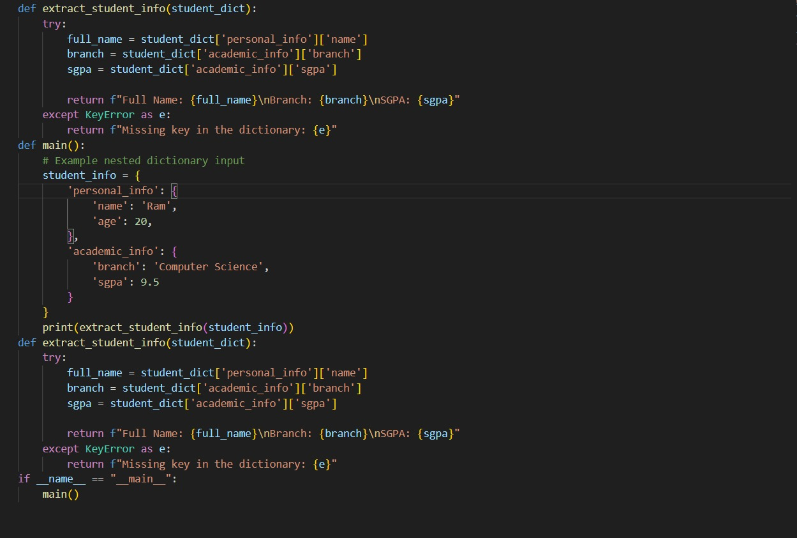
output:
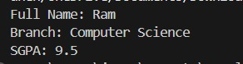
suggestion:
Ask the AI to first look at 2–3 example nested dictionaries that show how student information is stored. Using these examples, instruct the AI to write a Python function that correctly navigates the nested structure and extracts the Full Name, Branch, and SGPA. Make sure the function works even if the data is deeply nested. Finally, check the output using the given examples to confirm the values are extracted correctly.
Task Description #10
(Loops – Perfect Numbers in a Range)
Task: Generate a function using AI that displays all Perfect Numbers within a
user-specified range (e.g., 1 to 1000).
Instructions:
• A Perfect Number is a positive integer equal to the sum of its proper
divisors (excluding itself).
o Example: 6 = 1 + 2 + 3, 28 = 1 + 2 + 4 + 7 + 14.
• Use a for loop to find divisors of each number in the range.
• Validate correctness with known Perfect Numbers (6, 28, 496…).
• Ask AI to regenerate an optimized version (using divisor check only up to
√n).
Expected Output #12:
• Python program that lists Perfect Numbers in the given range.
• Optimized version with explanation
Prompt:
Code:
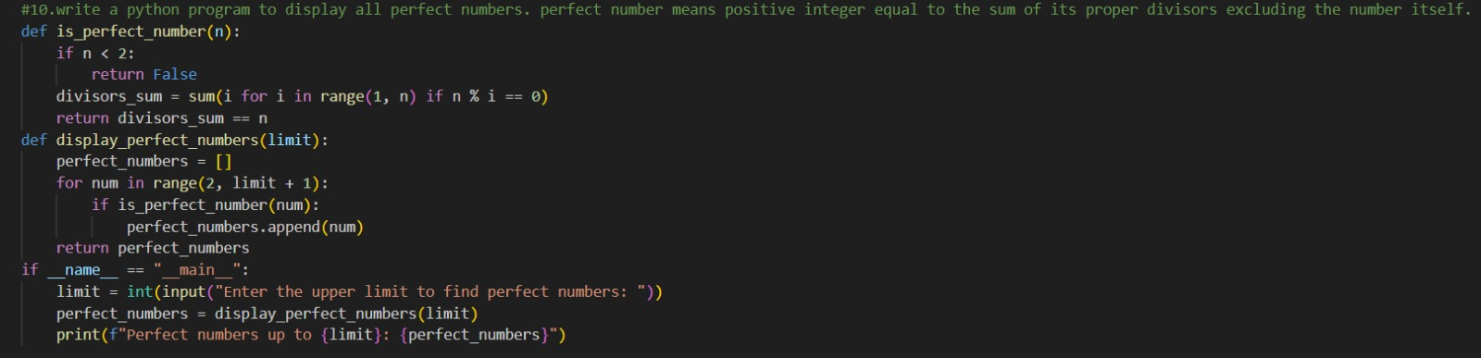
Output:
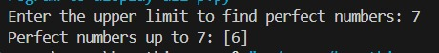
Suggestion:
Ask the AI to write a Python program that displays all Perfect Numbers within a user-given range (such as 1 to 1000) by using a for loop to find and sum proper divisors of each number. Verify the correctness of the output using known Perfect Numbers like 6, 28, and 496. After checking the logic, request the AI to regenerate an optimized version of the program by checking divisors only up to √n. Finally, ask for a short explanation comparing the normal and optimized approaches and why the optimized version is more efficient.

